**Assignment 1**

**Problem Statement** :-Create a responsive web page which shows the ecommerce/college/exam admin dashboard with sidebar and statistics in cards using HTML, CSS and Bootstrap.

**Sample Output 👇👇**

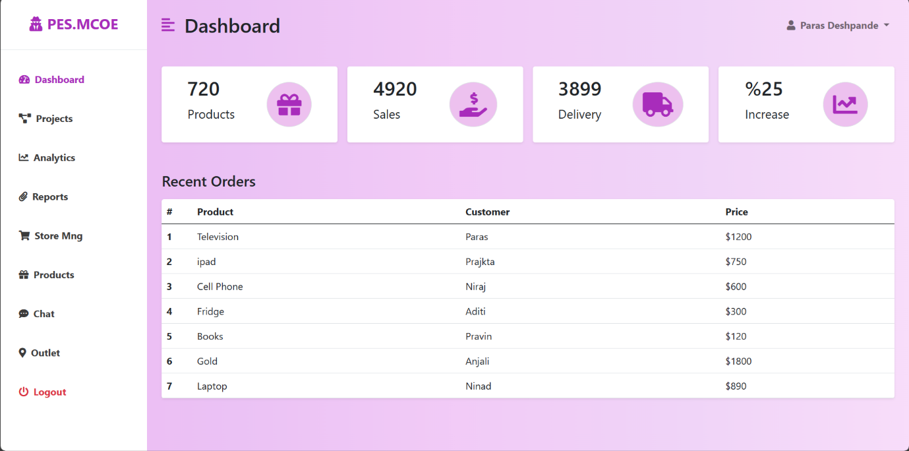

**Step 1 :- Add bootstrap links and CSS file**

<!DOCTYPE html>

<html lang="en">

<head>

    <meta charset="UTF-8">

    <meta name="viewport" content="width=device-width, initial-scale=1.0">

    <link href="https://cdn.jsdelivr.net/npm/bootstrap@5.0.0-beta3/dist/css/bootstrap.min.css" rel="stylesheet" />

    <link rel="stylesheet" href="https://cdnjs.cloudflare.com/ajax/libs/font-awesome/5.15.3/css/all.min.css" />

    <link rel="stylesheet" href="styles.css" />

    <title>Bootstap Admin Dashboard</title>

</head>

<body>

  <script src="https://cdn.jsdelivr.net/npm/bootstrap@5.0.0- ------> beta3/dist/js/bootstrap.bundle.min.js">

</script>

    <script>

        var el = document.getElementById("wrapper");

        var toggleButton = document.getElementById("menu-toggle");

        toggleButton.onclick = function () {

            el.classList.toggle("toggled");

        };

    </script>

</body>

</html>

**Step 2 :- Side Bar Code**

**SAMPE CODE 👇👇👇 Output👇👇👇**

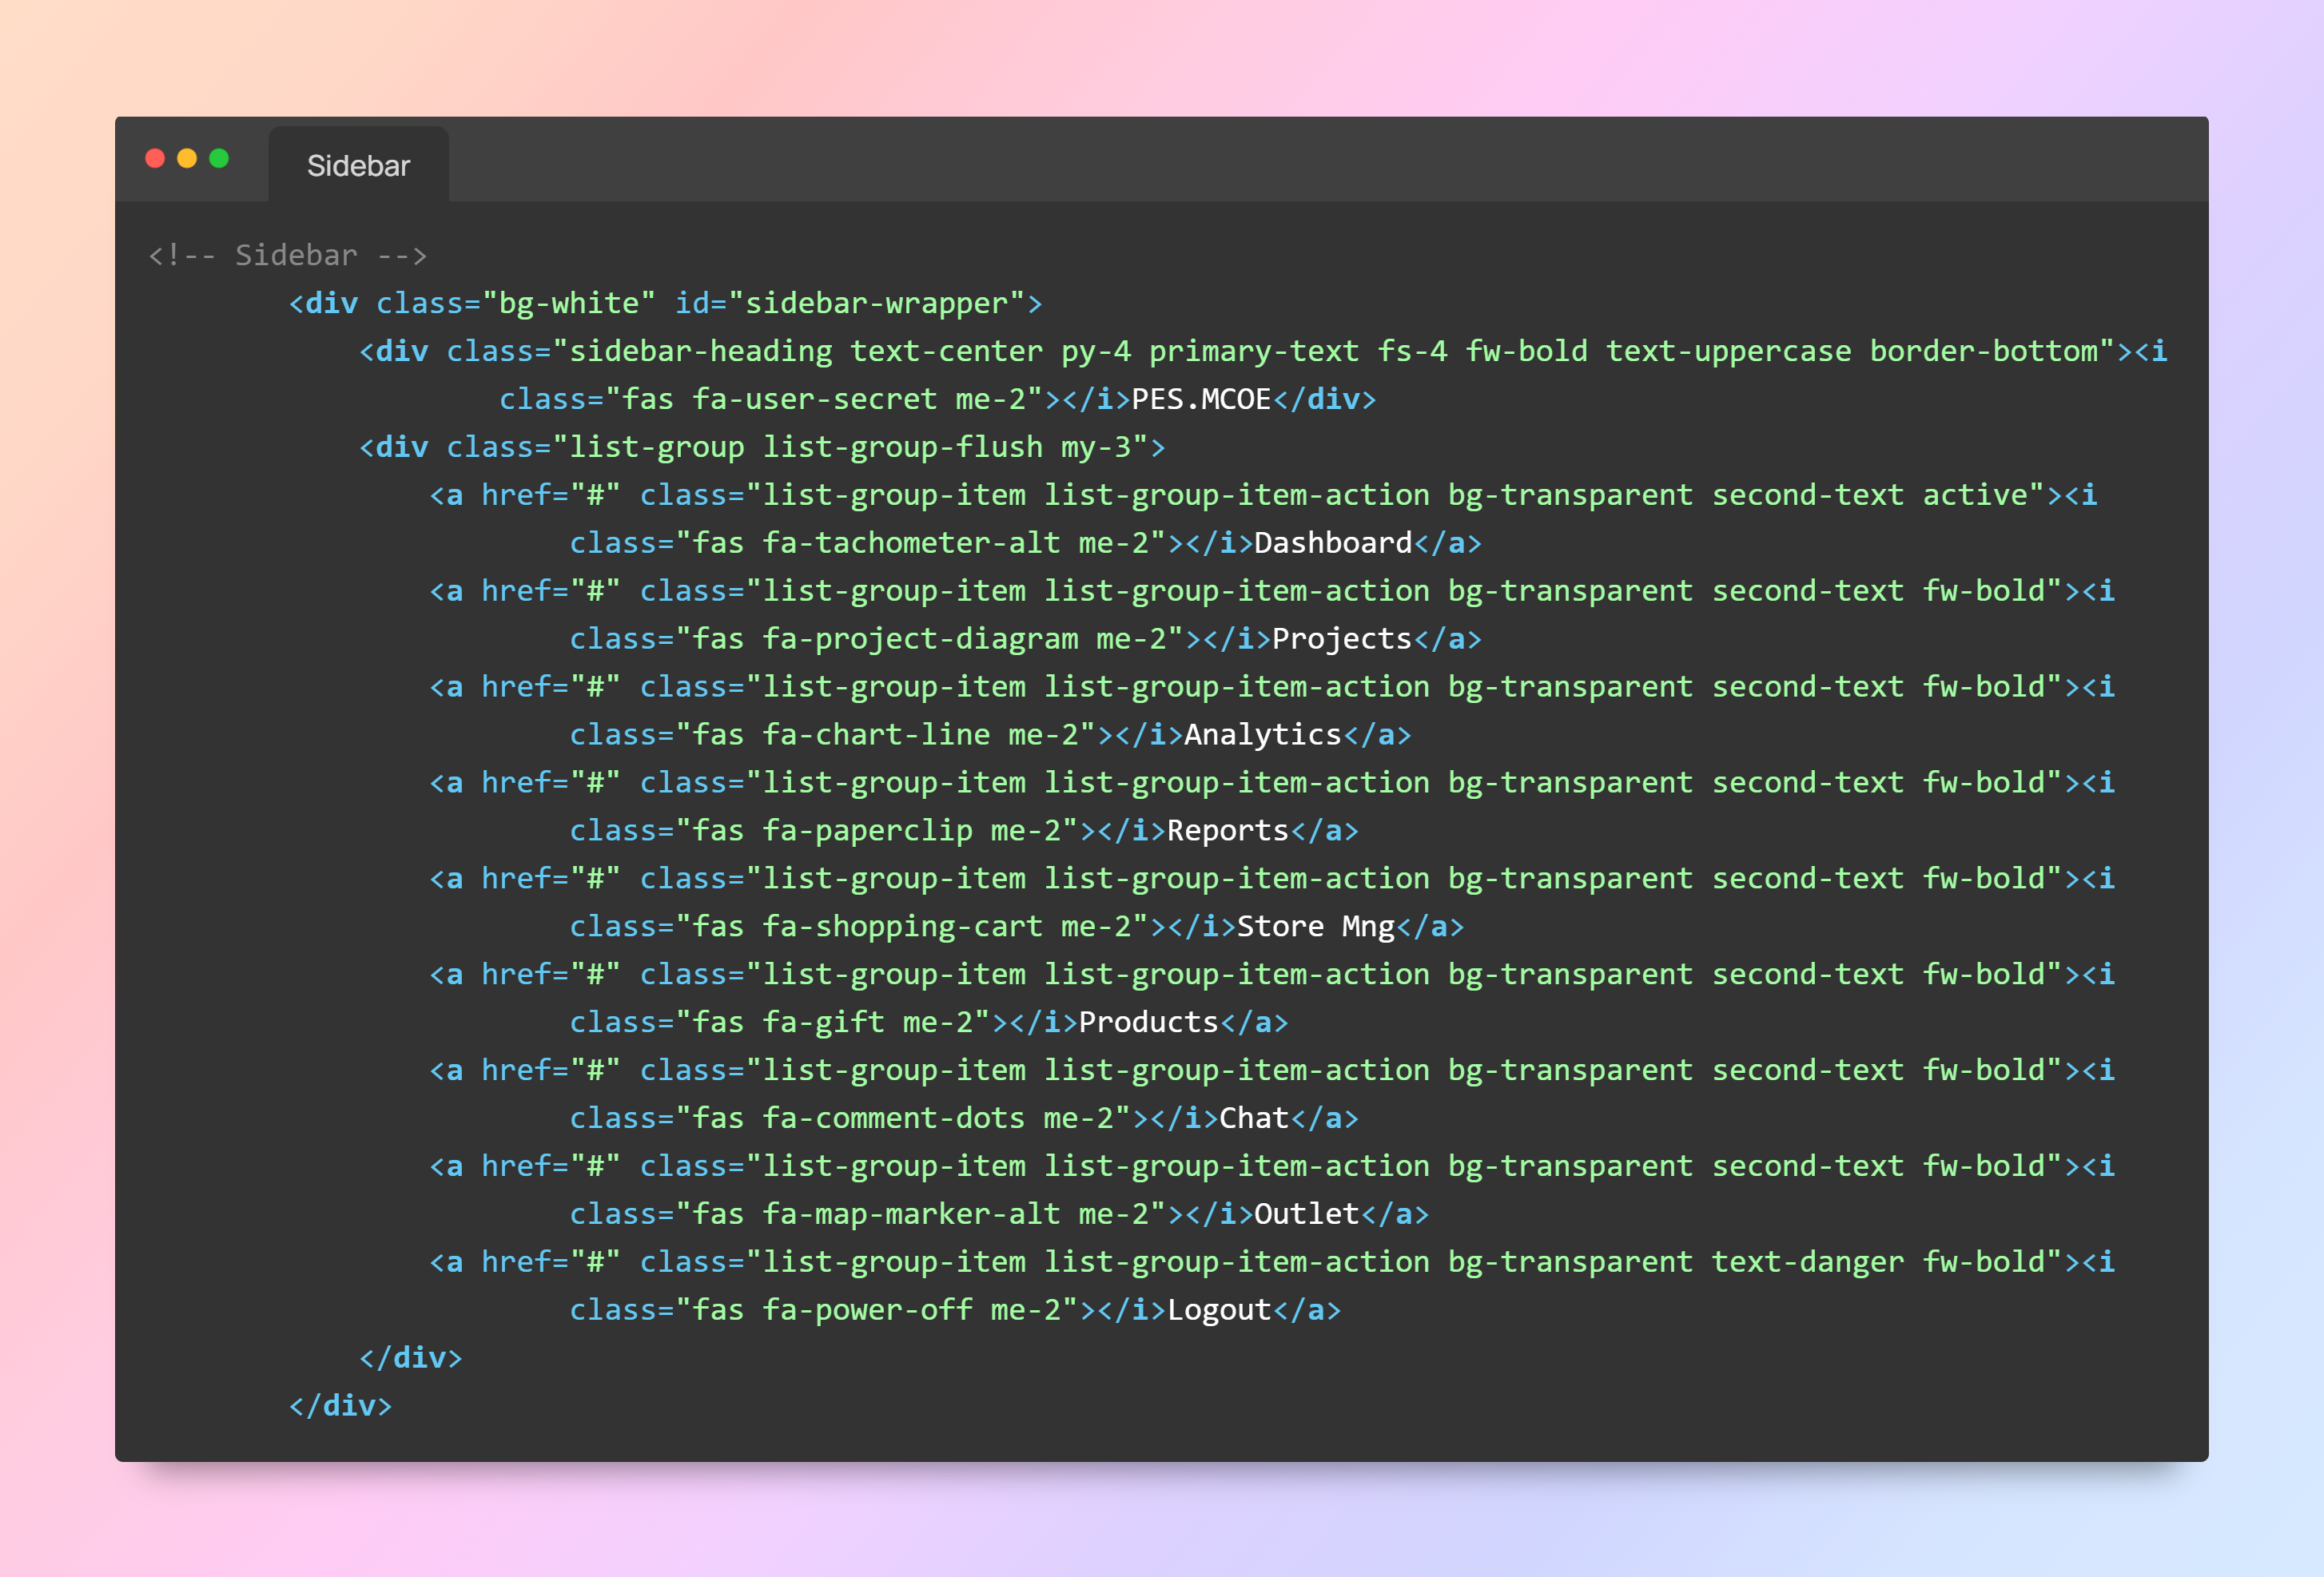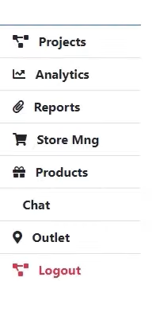

**Side Bar Code to Copy**

<!-- Sidebar -->

<div class="bg-white" id="sidebar-wrapper">

            <div class="sidebar-heading text-center py-4 primary-text fs-4 fw-bold text-uppercase border-bottom"><i

                    class="fas fa-user-secret me-2"></i>PES.MCOE</div>

            <div class="list-group list-group-flush my-3">

                <a href="#" class="list-group-item list-group-item-action bg-transparent second-text active"><i

                        class="fas fa-tachometer-alt me-2"></i>Dashboard</a>

                <a href="#" class="list-group-item list-group-item-action bg-transparent second-text fw-bold"><i

                        class="fas fa-project-diagram me-2"></i>Projects</a>

                <a href="#" class="list-group-item list-group-item-action bg-transparent second-text fw-bold"><i

                        class="fas fa-chart-line me-2"></i>Analytics</a>

                <a href="#" class="list-group-item list-group-item-action bg-transparent second-text fw-bold"><i

                        class="fas fa-paperclip me-2"></i>Reports</a>

                <a href="#" class="list-group-item list-group-item-action bg-transparent second-text fw-bold"><i

                        class="fas fa-shopping-cart me-2"></i>Store Mng</a>

                <a href="#" class="list-group-item list-group-item-action bg-transparent second-text fw-bold"><i

                        class="fas fa-gift me-2"></i>Products</a>

                <a href="#" class="list-group-item list-group-item-action bg-transparent second-text fw-bold"><i

                        class="fas fa-comment-dots me-2"></i>Chat</a>

                <a href="#" class="list-group-item list-group-item-action bg-transparent second-text fw-bold"><i

                        class="fas fa-map-marker-alt me-2"></i>Outlet</a>

                <a href="#" class="list-group-item list-group-item-action bg-transparent text-danger fw-bold"><i

                        class="fas fa-power-off me-2"></i>Logout</a>

            </div>

        </div>

<!-- /#sidebar-wrapper -->

**Step 3 :- Page Content**

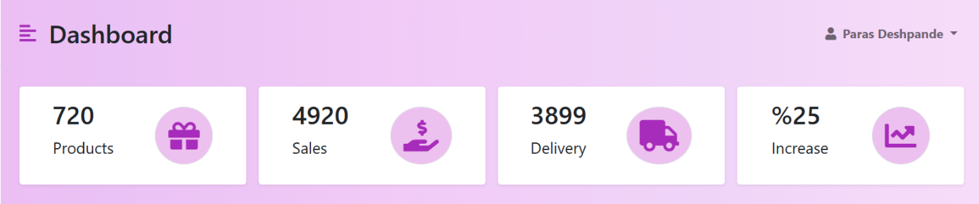

<!-- Page Content -->

        <div id="page-content-wrapper">

            <nav class="navbar navbar-expand-lg navbar-light bg-transparent py-4 px-4">

                <div class="d-flex align-items-center">

                    <i class="fas fa-align-left primary-text fs-4 me-3" id="menu-toggle"></i>

                    <h2 class="fs-2 m-0">Dashboard</h2>

                </div>

                <button class="navbar-toggler" type="button" data-bs-toggle="collapse"

                    data-bs-target="#navbarSupportedContent" aria-controls="navbarSupportedContent"

                    aria-expanded="false" aria-label="Toggle navigation">

                    <span class="navbar-toggler-icon"></span>

                </button>

                <div class="collapse navbar-collapse" id="navbarSupportedContent">

                    <ul class="navbar-nav ms-auto mb-2 mb-lg-0">

                        <li class="nav-item dropdown">

                            <a class="nav-link dropdown-toggle second-text fw-bold" href="#" id="navbarDropdown"

                                role="button" data-bs-toggle="dropdown" aria-expanded="false">

                                <i class="fas fa-user me-2"></i>Alok Ahirrao

                            </a>

                            <ul class="dropdown-menu" aria-labelledby="navbarDropdown">

                                <li><a class="dropdown-item" href="#">Profile</a></li>

                                <li><a class="dropdown-item" href="#">Settings</a></li>

                                <li><a class="dropdown-item" href="#">Logout</a></li>

                            </ul>

                        </li>

                    </ul>

                </div>

            </nav>

            <div class="container-fluid px-4">

                <div class="row g-3 my-2">

                    <div class="col-md-3">

                        <div class="p-3 bg-white shadow-sm d-flex justify-content-around align-items-center rounded">

                            <div>

                                <h3 class="fs-2">720</h3>

                                <p class="fs-5">Products</p>

                            </div>

                            <i class="fas fa-gift fs-1 primary-text border rounded-full secondary-bg p-3"></i>

                        </div>

                    </div>

                    <div class="col-md-3">

                        <div class="p-3 bg-white shadow-sm d-flex justify-content-around align-items-center rounded">

                            <div>

                                <h3 class="fs-2">4920</h3>

                                <p class="fs-5">Sales</p>

                            </div>

                            <i

                        class="fas fa-hand-holding-usd fs-1 primary-text border rounded-full secondary-bg p-3"></i>

                        </div>

                    </div>

                    <div class="col-md-3">

                        <div class="p-3 bg-white shadow-sm d-flex justify-content-around align-items-center rounded">

                            <div>

                                <h3 class="fs-2">3899</h3>

                                <p class="fs-5">Delivery</p>

                            </div>

                            <i class="fas fa-truck fs-1 primary-text border rounded-full secondary-bg p-3"></i>

                        </div>

                    </div>

                    <div class="col-md-3">

                        <div class="p-3 bg-white shadow-sm d-flex justify-content-around align-items-center rounded">

                            <div>

                                <h3 class="fs-2">%25</h3>

                                <p class="fs-5">Increase</p>

                            </div>

                            <i class="fas fa-chart-line fs-1 primary-text border rounded-full secondary-bg p-3"></i>

                        </div>

                    </div>

                </div>

**Step 4 :- Table Recent Orders**

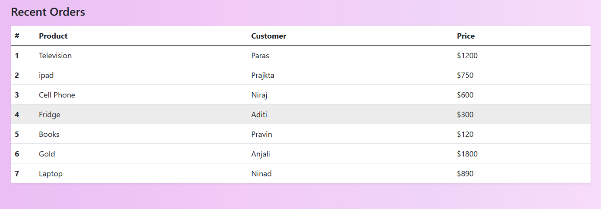

                <div class="row my-5">

                    <h3 class="fs-4 mb-3">Recent Orders</h3>

                    <div class="col">

                        <table class="table bg-white rounded shadow-sm  table-hover">

                            <thead>

                                <tr>

                                    <th scope="col" width="50">#</th>

                                    <th scope="col">Product</th>

                                    <th scope="col">Customer</th>

                                    <th scope="col">Price</th>

                                </tr>

                            </thead>

                            <tbody>

                                <tr>

                                    <th scope="row">1</th>

                                    <td>Television</td>

                                    <td>Alok</td>

                                    <td>$1200</td>

                                </tr>

<tr>

                                    <th scope="row">2</th>

                                    <td>Laptop</td>

                                    <td>Amey</td>

                                    <td>$750</td>

                                </tr>

                                <tr>

                                    <th scope="row">3</th>

                                    <td>Cell Phone</td>

                                    <td>Abhishek</td>

                                    <td>$600</td>

                                </tr>

                                <tr>

                                    <th scope="row">4</th>

                                    <td>Fridge</td>

                                    <td>Raj</td>

                                    <td>$300</td>

                                </tr>

                                <tr>

                                    <th scope="row">5</th>

                                    <td>Books</td>

                                    <td>Tanishk</td>

                                    <td>$120</td>

                                </tr>

                                <tr>

                                    <th scope="row">6</th>

                                    <td>Gold</td>

                                    <td>Rjesh</td>

                                    <td>$1800</td>

                                </tr>

                                <tr>

                                    <th scope="row">7</th>

                                    <td>Laptop</td>

                                    <td>Adiya</td>

                                    <td>$890</td>

                                </tr>

                            </tbody>

                        </table>

                    </div>

                </div>

            </div>

        </div>

    </div>

    <!-- /#page-content-wrapper -->

    </div>

Full code 👇👇

|  |  |
| --- | --- |
| 1  2  3  4  5  6  7  8  9  10  11  12  13  14  15  16  17  18  19  20  21  22  23  24  25  26  27  28  29  30  31  32  33  34  35  36  37  38  39  40  41  42  43  44  45  46  47  48  49  50  51  52  53  54  55  56  57  58  59  60  61  62  63  64  65  66  67  68  69  70  71  72  73  74  75  76  77  78  79  80  81  82  83  84  85  86  87  88  89  90  91  92  93  94  95  96  97  98  99  100  101  102  103  104  105  106  107  108  109  110  111  112  113  114  115  116  117  118  119  120  121  122  123  124  125  126  127  128  129  130  131  132  133  134  135  136  137  138  139  140  141  142  143  144  145  146  147  148  149  150  151  152  153  154  155  156  157  158  159  160  161  162  163  164  165  166  167  168  169  170  171  172  173  174  175  176  177  178  179  180  181  182  183  184  185  186  187  188  189  190  191  192  193  194  195 | <!DOCTYPE html>  <html lang="en">  <head>  <meta charset="UTF-8" />  <meta http-equiv="X-UA-Compatible" content="IE=edge" />  <meta name="viewport" content="width=device-width, initial-scale=1.0" />  <link href="https://cdn.jsdelivr.net/npm/bootstrap@5.0.0-beta3/dist/css/bootstrap.min.css" rel="stylesheet" />  <link rel="stylesheet" href="https://cdnjs.cloudflare.com/ajax/libs/font-awesome/5.15.3/css/all.min.css" />  <link rel="stylesheet" href="styles.css" />  <title>Bootstap Admin Dashboard</title>  </head>  <body>  <div class="d-flex" id="wrapper">  <!-- Sidebar -->  <div class="bg-white" id="sidebar-wrapper">  <div class="sidebar-heading text-center py-4 primary-text fs-4 fw-bold text-uppercase border-bottom"><i  class="fas fa-user-secret me-2"></i>PES**.MCOE**</div>  <div class="list-group list-group-flush my-3">  <a href="#" class="list-group-item list-group-item-action bg-transparent second-text active"><i  class="fas fa-tachometer-alt me-2"></i>Dashboard</a>  <a href="#" class="list-group-item list-group-item-action bg-transparent second-text fw-bold"><i  class="fas fa-project-diagram me-2"></i>Projects</a>  <a href="#" class="list-group-item list-group-item-action bg-transparent second-text fw-bold"><i  class="fas fa-chart-line me-2"></i>Analytics</a>  <a href="#" class="list-group-item list-group-item-action bg-transparent second-text fw-bold"><i  class="fas fa-paperclip me-2"></i>Reports</a>  <a href="#" class="list-group-item list-group-item-action bg-transparent second-text fw-bold"><i  class="fas fa-shopping-cart me-2"></i>Store Mng</a>  <a href="#" class="list-group-item list-group-item-action bg-transparent second-text fw-bold"><i  class="fas fa-gift me-2"></i>Products</a>  <a href="#" class="list-group-item list-group-item-action bg-transparent second-text fw-bold"><i  class="fas fa-comment-dots me-2"></i>Chat</a>  <a href="#" class="list-group-item list-group-item-action bg-transparent second-text fw-bold"><i  class="fas fa-map-marker-alt me-2"></i>Outlet</a>  <a href="#" class="list-group-item list-group-item-action bg-transparent text-danger fw-bold"><i  class="fas fa-power-off me-2"></i>Logout</a>  </div>  </div>  <!-- /**#sidebar-wrapper** -->  <!-- Page Content -->  <div id="page-content-wrapper">  <nav class="navbar navbar-expand-lg navbar-light bg-transparent py-4 px-4">  <div class="d-flex align-items-center">  <i class="fas fa-align-left primary-text fs-4 me-3" id="menu-toggle"></i>  <h2 class="fs-2 m-0">Dashboard</h2>  </div>  <button class="navbar-toggler" type="button" data-bs-toggle="collapse"  data-bs-target="#navbarSupportedContent" aria-controls="navbarSupportedContent"  aria-expanded="false" aria-label="Toggle navigation">  <span class="navbar-toggler-icon"></span>  </button>  <div class="collapse navbar-collapse" id="navbarSupportedContent">  <ul class="navbar-nav ms-auto mb-2 mb-lg-0">  <li class="nav-item dropdown">  <a class="nav-link dropdown-toggle second-text fw-bold" href="#" id="navbarDropdown"  role="button" data-bs-toggle="dropdown" aria-expanded="false">  <i class="fas fa-user me-2"></i>Alok Ahirrao  </a>  <ul class="dropdown-menu" aria-labelledby="navbarDropdown">  <li><a class="dropdown-item" href="#">Profile</a></li>  <li><a class="dropdown-item" href="#">Settings</a></li>  <li><a class="dropdown-item" href="#">Logout</a></li>  </ul>  </li>  </ul>  </div>  </nav>  <div class="container-fluid px-4">  <div class="row g-3 my-2">  <div class="col-md-3">  <div class="p-3 bg-white shadow-sm d-flex justify-content-around align-items-center rounded">  <div>  <h3 class="fs-2">720</h3>  <p class="fs-5">Products</p>  </div>  <i class="fas fa-gift fs-1 primary-text border rounded-full secondary-bg p-3"></i>  </div>  </div>  <div class="col-md-3">  <div class="p-3 bg-white shadow-sm d-flex justify-content-around align-items-center rounded">  <div>  <h3 class="fs-2">4920</h3>  <p class="fs-5">Sales</p>  </div>  <i  class="fas fa-hand-holding-usd fs-1 primary-text border rounded-full secondary-bg p-3"></i>  </div>  </div>  <div class="col-md-3">  <div class="p-3 bg-white shadow-sm d-flex justify-content-around align-items-center rounded">  <div>  <h3 class="fs-2">3899</h3>  <p class="fs-5">Delivery</p>  </div>  <i class="fas fa-truck fs-1 primary-text border rounded-full secondary-bg p-3"></i>  </div>  </div>  <div class="col-md-3">  <div class="p-3 bg-white shadow-sm d-flex justify-content-around align-items-center rounded">  <div>  <h3 class="fs-2">%25</h3>  <p class="fs-5">Increase</p>  </div>  <i class="fas fa-chart-line fs-1 primary-text border rounded-full secondary-bg p-3"></i>  </div>  </div>  </div>  <div class="row my-5">  <h3 class="fs-4 mb-3">Recent Orders</h3>  <div class="col">  <table class="table bg-white rounded shadow-sm table-hover">  <thead>  <tr>  <th scope="col" width="50">#</th>  <th scope="col">Product</th>  <th scope="col">Customer</th>  <th scope="col">Price</th>  </tr>  </thead>  <tbody>  <tr>  <th scope="row">1</th>  <td>Television</td>  <td>Alok</td>  <td>$1200</td>  </tr>  <tr>  <th scope="row">2</th>  <td>Laptop</td>  <td>Amey</td>  <td>$750</td>  </tr>  <tr>  <th scope="row">3</th>  <td>Cell Phone</td>  <td>Abhishek</td>  <td>$600</td>  </tr>  <tr>  <th scope="row">4</th>  <td>Fridge</td>  <td>Raj</td>  <td>$300</td>  </tr>  <tr>  <th scope="row">5</th>  <td>Books</td>  <td>Tanishk</td>  <td>$120</td>  </tr>  <tr>  <th scope="row">6</th>  <td>Gold</td>  <td>Rajesh</td>  <td>$1800</td>  </tr>  <tr>  <th scope="row">7</th>  <td>Laptop</td>  <td>Adiya</td>  <td>$890</td>  </tr>  </tbody>  </table>  </div>  </div>  </div>  </div>  </div>  <!-- /**#page-content-wrapper** -->  </div>  <script src="https://cdn.jsdelivr.net/npm/bootstrap@5.0.0-beta3/dist/js/bootstrap.bundle.min.js"></script>  <script>  var el = document**.getElementById**("wrapper");  var toggleButton = document**.getElementById**("menu-toggle");  toggleButton**.onclick** = function () {  el.classList.toggle("toggled");  };  </script>  </body>  </html> |

**CSS FULL CODE 👇👇**

|  |  |
| --- | --- |
| 1  2  3  4  5  6  7  8  9  10  11  12  13  14  15  16  17  18  19  20  21  22  23  24  25  26  27  28  29  30  31  32  33  34  35  36  37  38  39  40  41  42  43  44  45  46  47  48  49  50  51  52  53  54  55  56  57  58  59  60  61  62  63  64  65  66  67  68  69  70  71  72  73  74  75  76  77  78  79  80  81  82  83  84  85  86  87  88  89  90  91  92  93  94  95 | **:root** {  --main-bg-**color**: **#009d63**;  --main-**text**-**color**: **#009d63**;  --second-**text**-**color**: **#3b3b3b**;  --second-bg-**color**: **#c1efde**;  }  **.primary-text** {  **color**: var(--main-**text**-**color**);  }  **.second-text** {  **color**: var(--second-**text**-**color**);  }  **.primary-bg** {  **background-color**: var(--main-bg-**color**);  }  **.secondary-bg** {  **background-color**: var(--second-bg-**color**);  }  **.rounded-full** {  **border**-radius: **100**%;  }  **#wrapper** {  **overflow-x**: **hidden**;  **background-image**: linear-gradient(  to **right**,  **#baf3d7**,  **#c2f5de**,  **#cbf7e4**,  **#d4f8ea**,  **#ddfaef**  );  }  **#sidebar-wrapper** {  **min-height**: **100**vh;  **margin-left**: **-15**rem;  -webkit-transition: **margin** **0.25s** ease-out;  -moz-transition: **margin** **0.25s** ease-out;  -o-transition: **margin** **0.25s** ease-out;  transition: **margin** **0.25s** ease-out;  }  **#sidebar-wrapper** **.sidebar-heading** {  **padding**: **0**.**875**rem **1**.**25**rem;  **font-size**: **1**.**2**rem;  }  **#sidebar-wrapper** **.list-group** {  **width**: **15**rem;  }  **#page-content-wrapper** {  **min-width**: **100**vw;  }  **#wrapper.toggled** **#sidebar-wrapper** {  **margin-left**: **0**;  }  **#menu-toggle** {  **cursor**: **pointer**;  }  **.list-group-item** {  **border**: **none**;  **padding**: **20px** **30px**;  }  **.list-group-item.active** {  **background-color**: **transparent**;  **color**: var(--main-**text**-**color**);  **font-weight**: **bold**;  **border**: **none**;  }  **@media** (min-width: 768px) {  **#sidebar-wrapper** {  **margin-left**: **0**;  }  **#page-content-wrapper** {  **min-width**: **0**;  **width**: **100**%;  }  **#wrapper.toggled** **#sidebar-wrapper** {  **margin-left**: **-15**rem;  }  } |